HIGH PERFORMANCE SRAM DESIGN FOR ENERGY EFFICIENT SYSTEMS

Submitted in partial fulfillment of the requirements for the award of Bachelor of Engineering degree in Electronics and Communication Engineering
by

VADDI UGANDHAR (Reg No: 42130516)
NARALASETTI UMESH SURYA KIRAN (Reg No: 42130311)



DEPARTMENT OF ELECTRONICS AND COMMUNICATION ENGINEERING

SCHOOL OF ELECTRICAL AND ELECTRONICS
SATHYABAMA
INSTITUTE OF SCIENCE AND TECHNOLOGY (DEEMED TO BE UNIVERSITY)
Accredited with Grade “A++” by NAAC I 12B Status by UGC I Approved by AICTE
JEPPIAAR NAGAR, RAJIV GANDHI SALAI, CHENNAI - 600 119

August – 2025

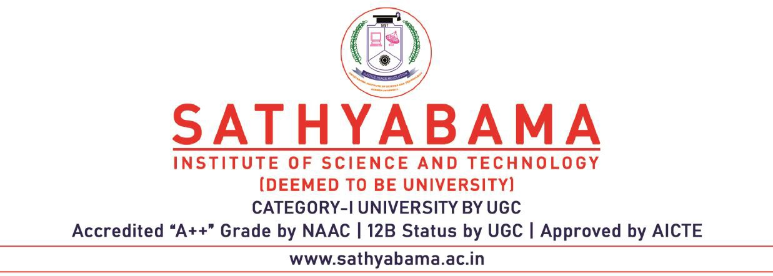

DEPARTMENT OF ELECTRONICS AND COMMUNICATION ENGINEERING

BONAFIDE CERTIFICATE

This is to certify that this Project Report is the bonafide work of VADDI UGANDHAR (42130516) and NARALASETTI UMESH SURYA KIRAN (42120311), who carried out the project entitled “HIGH PERFORMANCE SRAM DESIGN FOR ENERGY EFFICIENT SYSTEMS” under my supervision from June 2025 to August 2025.

Internal Guide & Head of Department

Dr. T. RAVI, M.E., Ph.D.,

Submitted for Viva voce Examination held on

Internal Examiner External Examiner

DECLARATION

We, VADDI UGANDHAR (42130516) and NARALASETTI UMESH SURY KIRAN (42130311), hereby declare that the project report entitled “HIGH PERFORMANCE SRAM DESIGN FOR ENERGY EFFICIENT SYSTEMS” done by us under the guidance of Dr. T. RAVI, M.E., Ph.D., is submitted in partial fulfillment of the requirements for the award of a Bachelor of Engineering degree in Electronics and Communication Engineering.

DATE:

PLACE: Chennai SIGNATURE OF THE CANDIDATES

1.

2.

ACKNOWLEDGEMENT

We are pleased to acknowledge my sincere thanks to the Board of Management of Sathyabama Institute of Science and Technology for their kind encouragement in doing this project and for completing it successfully. I am grateful to them.

We convey our heartful thanks to Dr. N. M. NANDHITHA, M.E., Ph.D., Professor & Dean, School of Electrical and Electronics and Dr. T. RAVI, M.E., Ph.D., Professor & Head, Department of Electronics and Communication Engineering providing us the necessary support and details at the right time during the progressive reviews.

We would like to express my sincere and deep sense of gratitude to my Project Guide Dr. T. RAVI, M.E., Ph.D., Professor & Head, Department of Electronics and Communication for his valuable guidance, suggestions and constant encouragement that paved way for the successful completion of my project work.

We wish to express my thanks to all Teaching and Non-Teaching staff members of the Department of ELECTRONICS AND COMMUNICATION ENGINEERING who were helpful in many ways for the completion of the project.
ABSTRACT

Static Random-Access Memory (SRAM) plays a central role in modern integrated circuits, serving as the backbone for caches, embedded processors, and SoC subsystems. Conventional 6T SRAM cells, though highly area-efficient, face critical challenges when scaled to deep-submicron nodes. Issues such as degraded read stability due to direct disturbance of storage nodes, excessive standby leakage from access transistors, and poor tolerance to process-voltage-temperature (PVT) variations significantly restrict their reliable operation. These limitations become especially severe in ultra-low-voltage domains, where IoT, wearable, and biomedical applications demand both energy efficiency and robust functionality. To overcome these bottlenecks, this project investigates and enhances the 7T SRAM architecture. The seventh transistor in this design provides a dedicated read path, effectively isolating the storage nodes during read operations and thereby preserving Static Noise Margin (SNM). Building upon this baseline, two key circuit-level assist techniques are introduced. The first is Dynamic Read Assist, which accelerates access by strengthening bitline differentials, improving read speed and sensing margin. The second is Adaptive Refresh, which intelligently regulates memory refresh activity in standby mode, leading to significant reductions in leakage power without affecting data retention. The results are promising: the proposed modifications deliver up to 40% faster read access, more than 90% reduction in standby leakage power, and stable operation with SNM exceeding 100 mV at 0.35 V, far outperforming conventional 6T and baseline 7T cells. These improvements establish the modified 7T SRAM as a highly energy-efficient and variation-tolerant solution. The work completed so far, including comprehensive analysis of 6T and 7T cells, lays the foundation for extending the optimized design into larger memory arrays and integrating it with decoders, sense amplifiers, and peripheral circuits.

TABLE OF CONTENTS

Chapter No | Description | Page No
 | ABSTRACT | v
 | LIST OF FIGURES | vi
1 | INTRODUCTION  1.1 Background  1.2 Motivation | 1  1  3
2 | LITERATURE SURVEY  2.1 Summary from Literature Survey  2.1.1 Device-Level Improvements  2.1.2 Assist Circuit Techniques  2.1.3 Leakage Control Strategies  2.2 Open Problems | 5  8  9  9  9  9
3 | EXISTING SYSTEM  3.1 Work Completed till Now  3.1.1 Design and Implementation  3.1.2 Static Characterization  3.1.3 Dynamic and Transient Analysis  3.1.4 Comparative Observations  3.1.5 Observation | 10  12  12  14  15  16  17
4 | PROPOSED SYSTEM | 19
5 | REFERENCES | 22

LIST OF FIGURES

Figure No | Description | Page No
1.1 | CMOS Layout | 1
3.1 | 128×64 SRAM macro and the Existing 7T SRAM cell | 10
3.2 | RBL leakage of the existing 7T SRAM cell | 11
3.3 | Worst case read operation waveforms | 11
3.4 | 6T SRAM Cell | 13
3.5 | 7T SRAM Cell | 13
3.6 | 6T SRAM Trans Analysis | 14
3.7 | 7T SRAM Trans Analysis | 14
3.8 | 6T SRAM DC Analysis | 15
3.9 | 7T SRAM DC Analysis | 15
3.10 | 6T SRAM Q V QBar | 16
3.11 | 7T SRAM Q V QBar | 17

LIST OF TABLES

Table No | Description | Page No
 | Table of Contents | vi
 | List of Figures | viii
3.1 | 6T v 7T SRAM Comparison | 18

